Practical(5.1.2)
Aim: Write a program to calculate the total marks, aggregate percentage, and grade of a student based on marks in four subjects. The grade is determined as follows:
Aggregate > 75 : Distinction. Aggregate >= 60 and < 75 : First Division. Aggregate >= 50 and < 60 : Second Division. Aggregate >= 40 and < 50 : Third Division. Aggregate < 40 : Fail.

Algorithm:
- Start
- Read four marks: m1, m2, m3, m4
- Calculate total marks:- total = m1 + m2 + m3 + m4
- Calculate aggregate percentage percentage = total / 4
- If percentage > 75 Print "Distinction"
- Else if percentage >= 60 and percentage < 75 Print "First Division"
- Else if percentage >= 50 and percentage < 60 Print "Second Division"
- Else if percentage >= 40 and percentage < 50 Print "Third Division"
- Else Print "Fail"
- Print total marks
- Print aggregate percentage
- Stop.

FLOWCHART
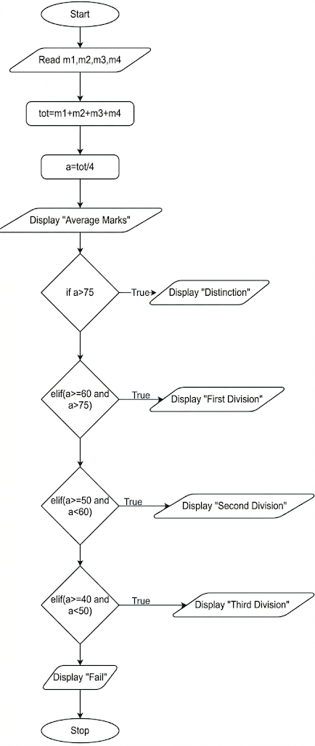

EXECUTION
